ACOUSTICAL ULTRASONIC CLEANER
MODEL: LEO-50
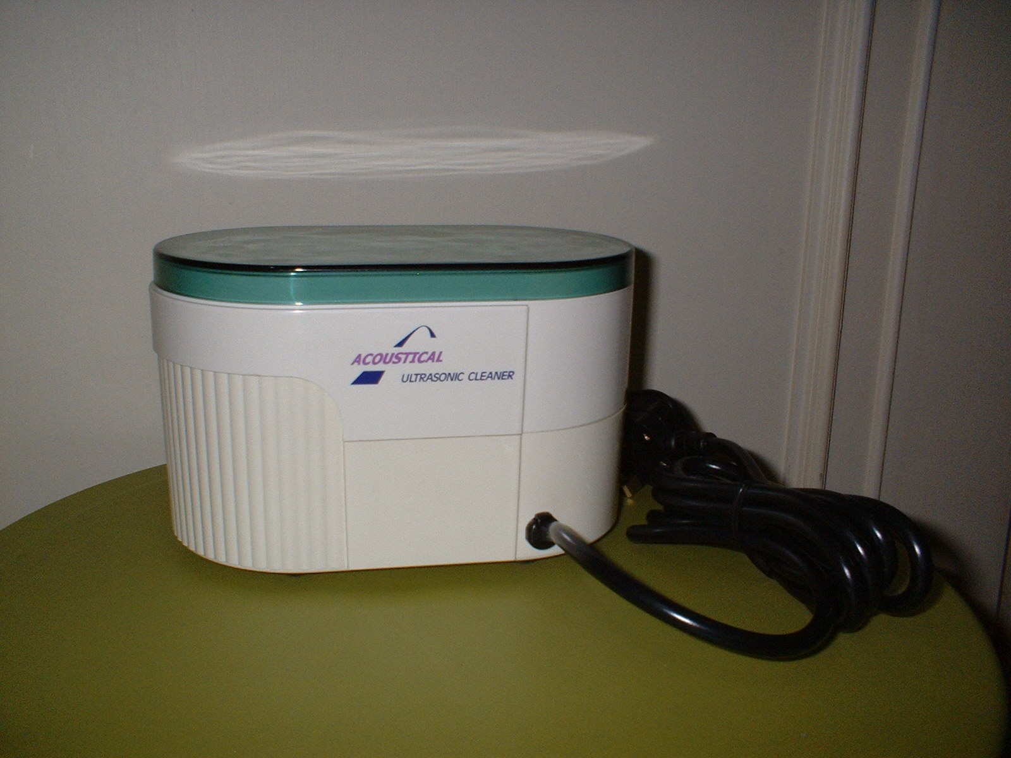

Equipment Specifications:
Internal Tank Size: 168x69x55mm
External Dimension: 193x116x118mm
Capacity: 600ml
Material:
- Internal Tank: Stainless Steel SUS 304
- External Body: ABS (UL Fire Resistant)
- Cover: Semi-Transparent Plastic PS
Ultrasonic Output: 50W
Output Frequency: 46 KHz
Electronic Timer: 5 minutes auto power-of (fixed timer)
Power Switch: 1 Button Soft Touch ON/OFF Control
Power Source: 110/220V AC Single Phase 50/60 Hz
Net Weight: 1.0Kg

Why and how it works: The Acoustical Ultrasonic Cleaner cleans with remarkable efficiency by using ultrasonic waves of 46,000 cycles per second generated through the cleansing liquid. The action of this longitudinal wave causes dielectric pressure to build up, resulting in numerous micro-vacuum bubbles producing the effect of cavitation. When these bubbles explode, the explosion force removes the encrusted dirt and grime even in tiny hard to reach corners.

Cleaning applications: Spectacles, watch parts, jewelry, diamonds, glass items, signature chops, toothbrushes, dentures, razor blades, machine nozzles, baby bottles, pendants, surgical tools, and gold objects.

Biological applications: Extract carbon dioxide from beer, dilute the alcoholic content of whiskey reducing its side-effects, purify Japanese wine, blend milk powder, stir instant coffee, and dissolve dried-up substances e.g. cosmetics, lotions etc for future use.

Selling Price = $50

Attractive package:
Discount of 50% for bulk purchase of more than 10 units
Discount of 20% for referrals
1 year warranty
1 year service and support
1 year management consulting and training

Acoustical Technologies Singapore Pte Ltd
209-212 Innovation Centre, NTU, 16 Nanyang Drive, Singapore 637722
Tel: 65-67913242
Fax: 65-67913665
Email: sales@acousticaltechnologies.com
Website: http://www.acousticaltechnologies.com

